**CPI effect:**

Consumer Price Index(CPI) is the statistical estimate constructed using prices of a sample of representative items whose prices are collected periodically.

The Consumer Price Index (CPI) is a measure that examines theweighted average of prices of a basket of consumer goods and services, such as transportation, food and medical care.

So we took the basket of goods of India and observed its effects on SKU

Basket of goods in India is made into 6 groups:

1. Food and Beverages
2. Pan, tobacco and intoxicants
3. Clothing and Footwear
4. Housing
5. Fuel and Light
6. Miscellaneous

For each Group we have given a specific weightage for calculation of CPI

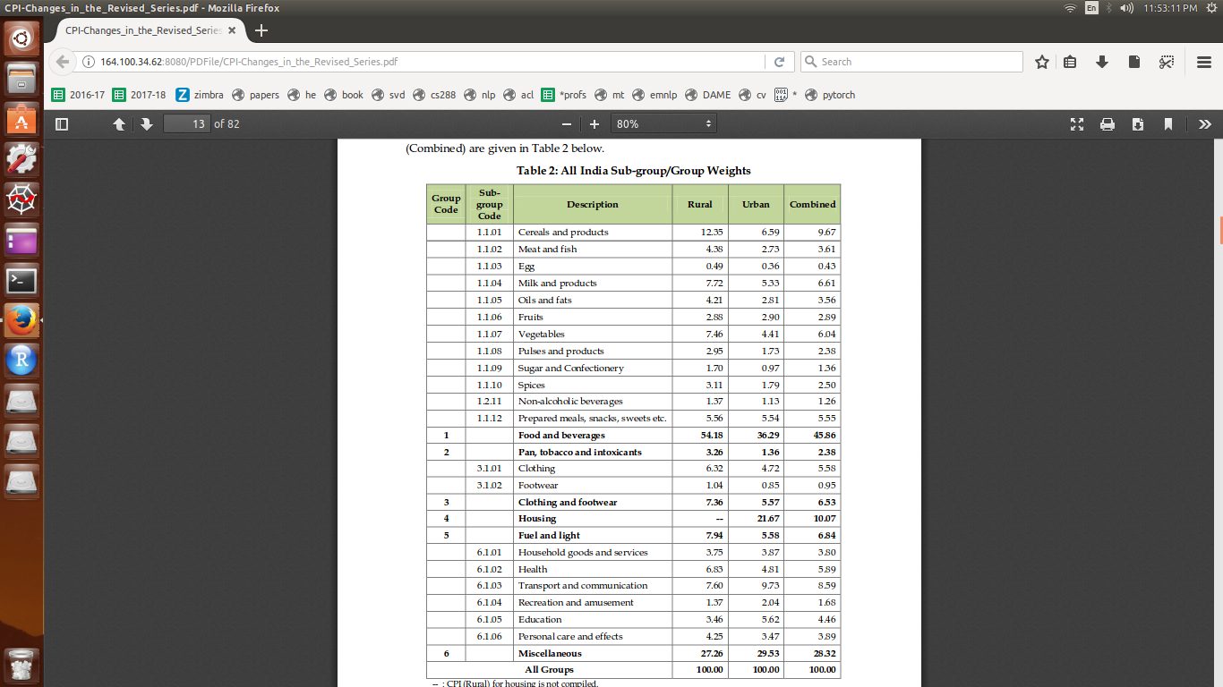

We also found weightage for each product like potato, washing machine etc,... from that we took the weightage for each SKU.



With this we can say how total sales of SKU changes if CPI changes.

We also found the weightage of CPI for individual states

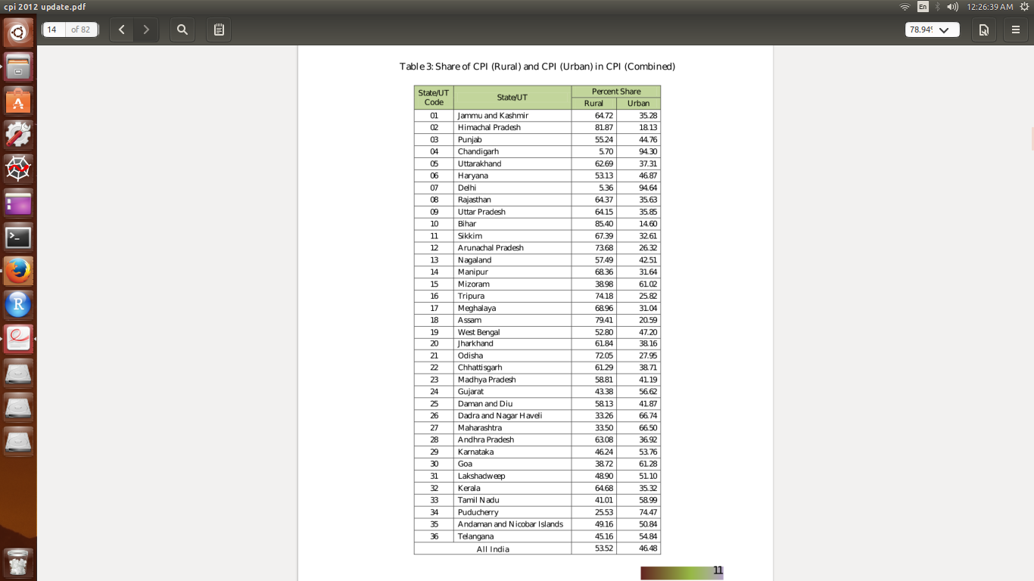With increase of CPI we can say that overall price level is increasing(inflection), we can’t say about the individual prices of SKUs.